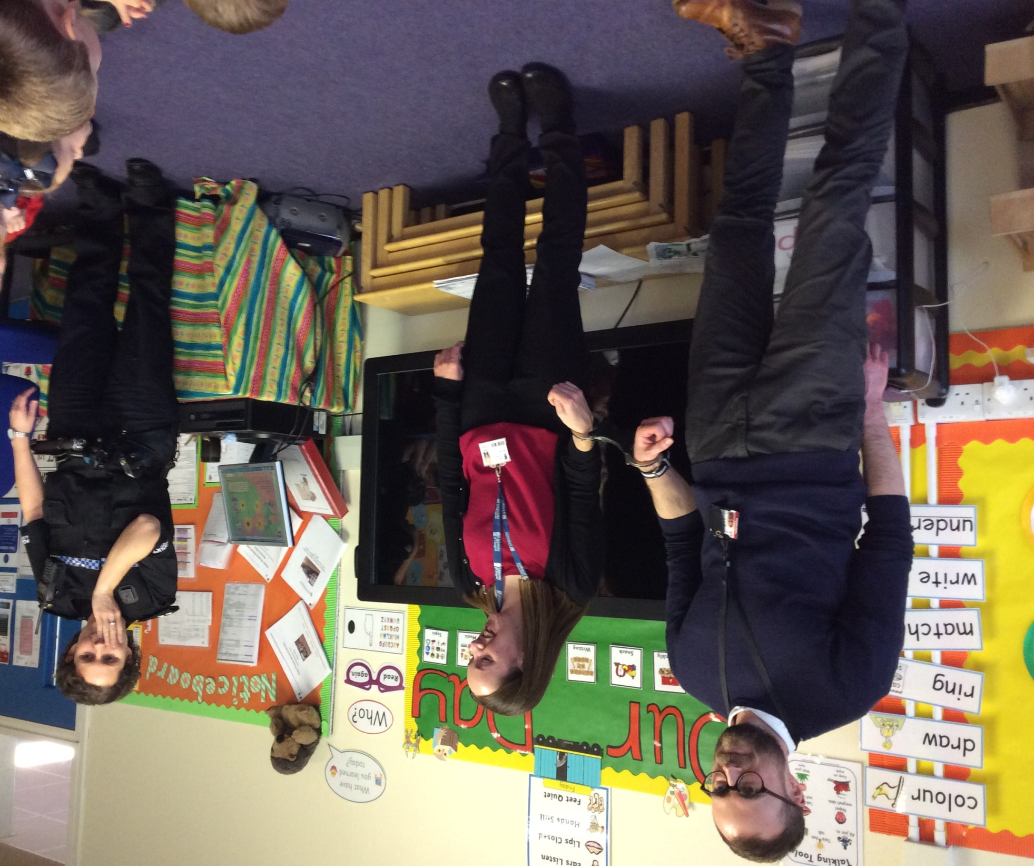
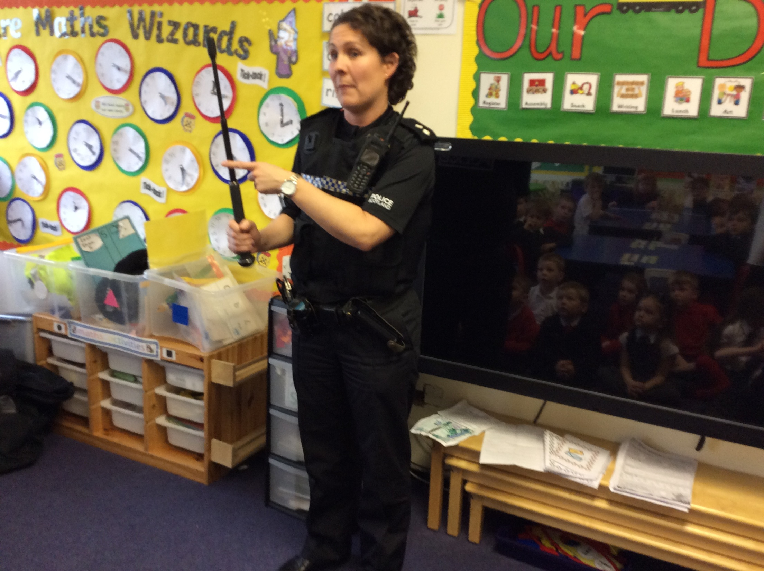
Primary 1 enjoyed a visit from PC Claire, who talked to us about staying safe outside of school.

PC Claire offered a demonstration of how to use some of her equipment (we unlocked the handcuffs eventually!).

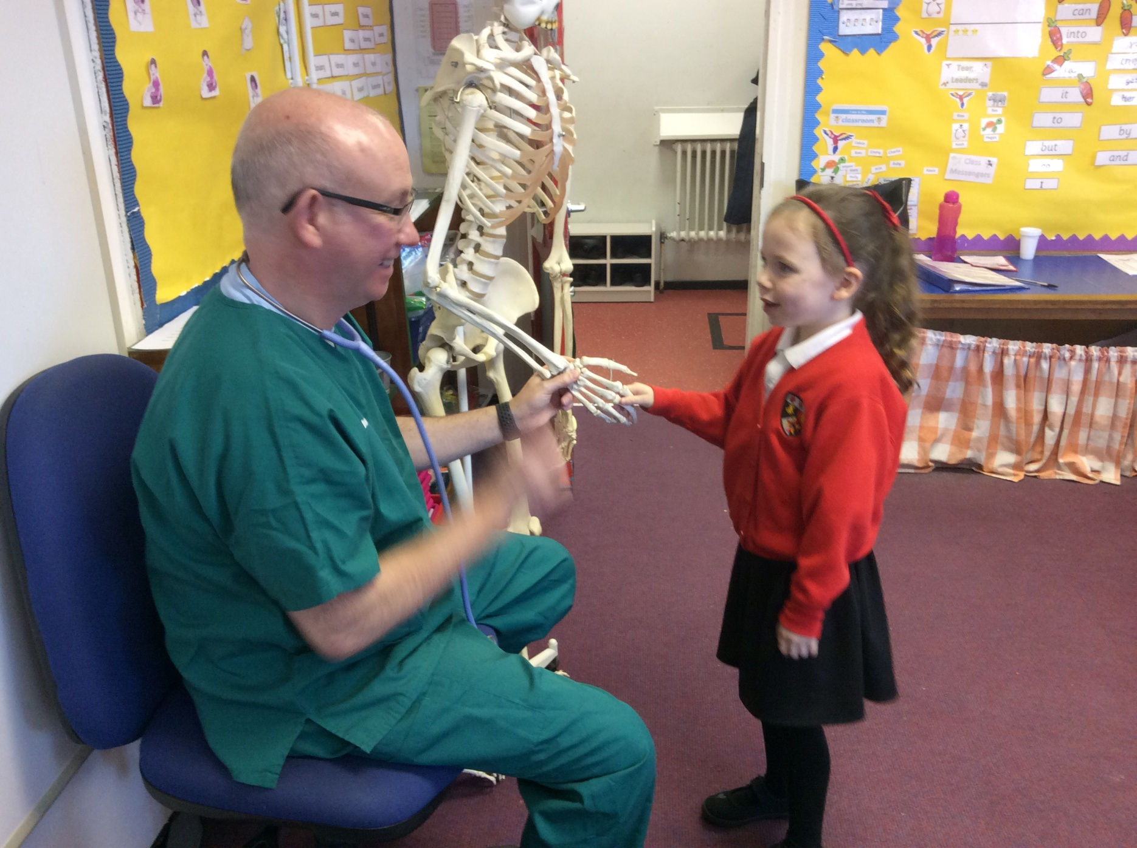
Dr Taylor also visited us to teach us all about the role of a doctor, and how they help people who are unwell.
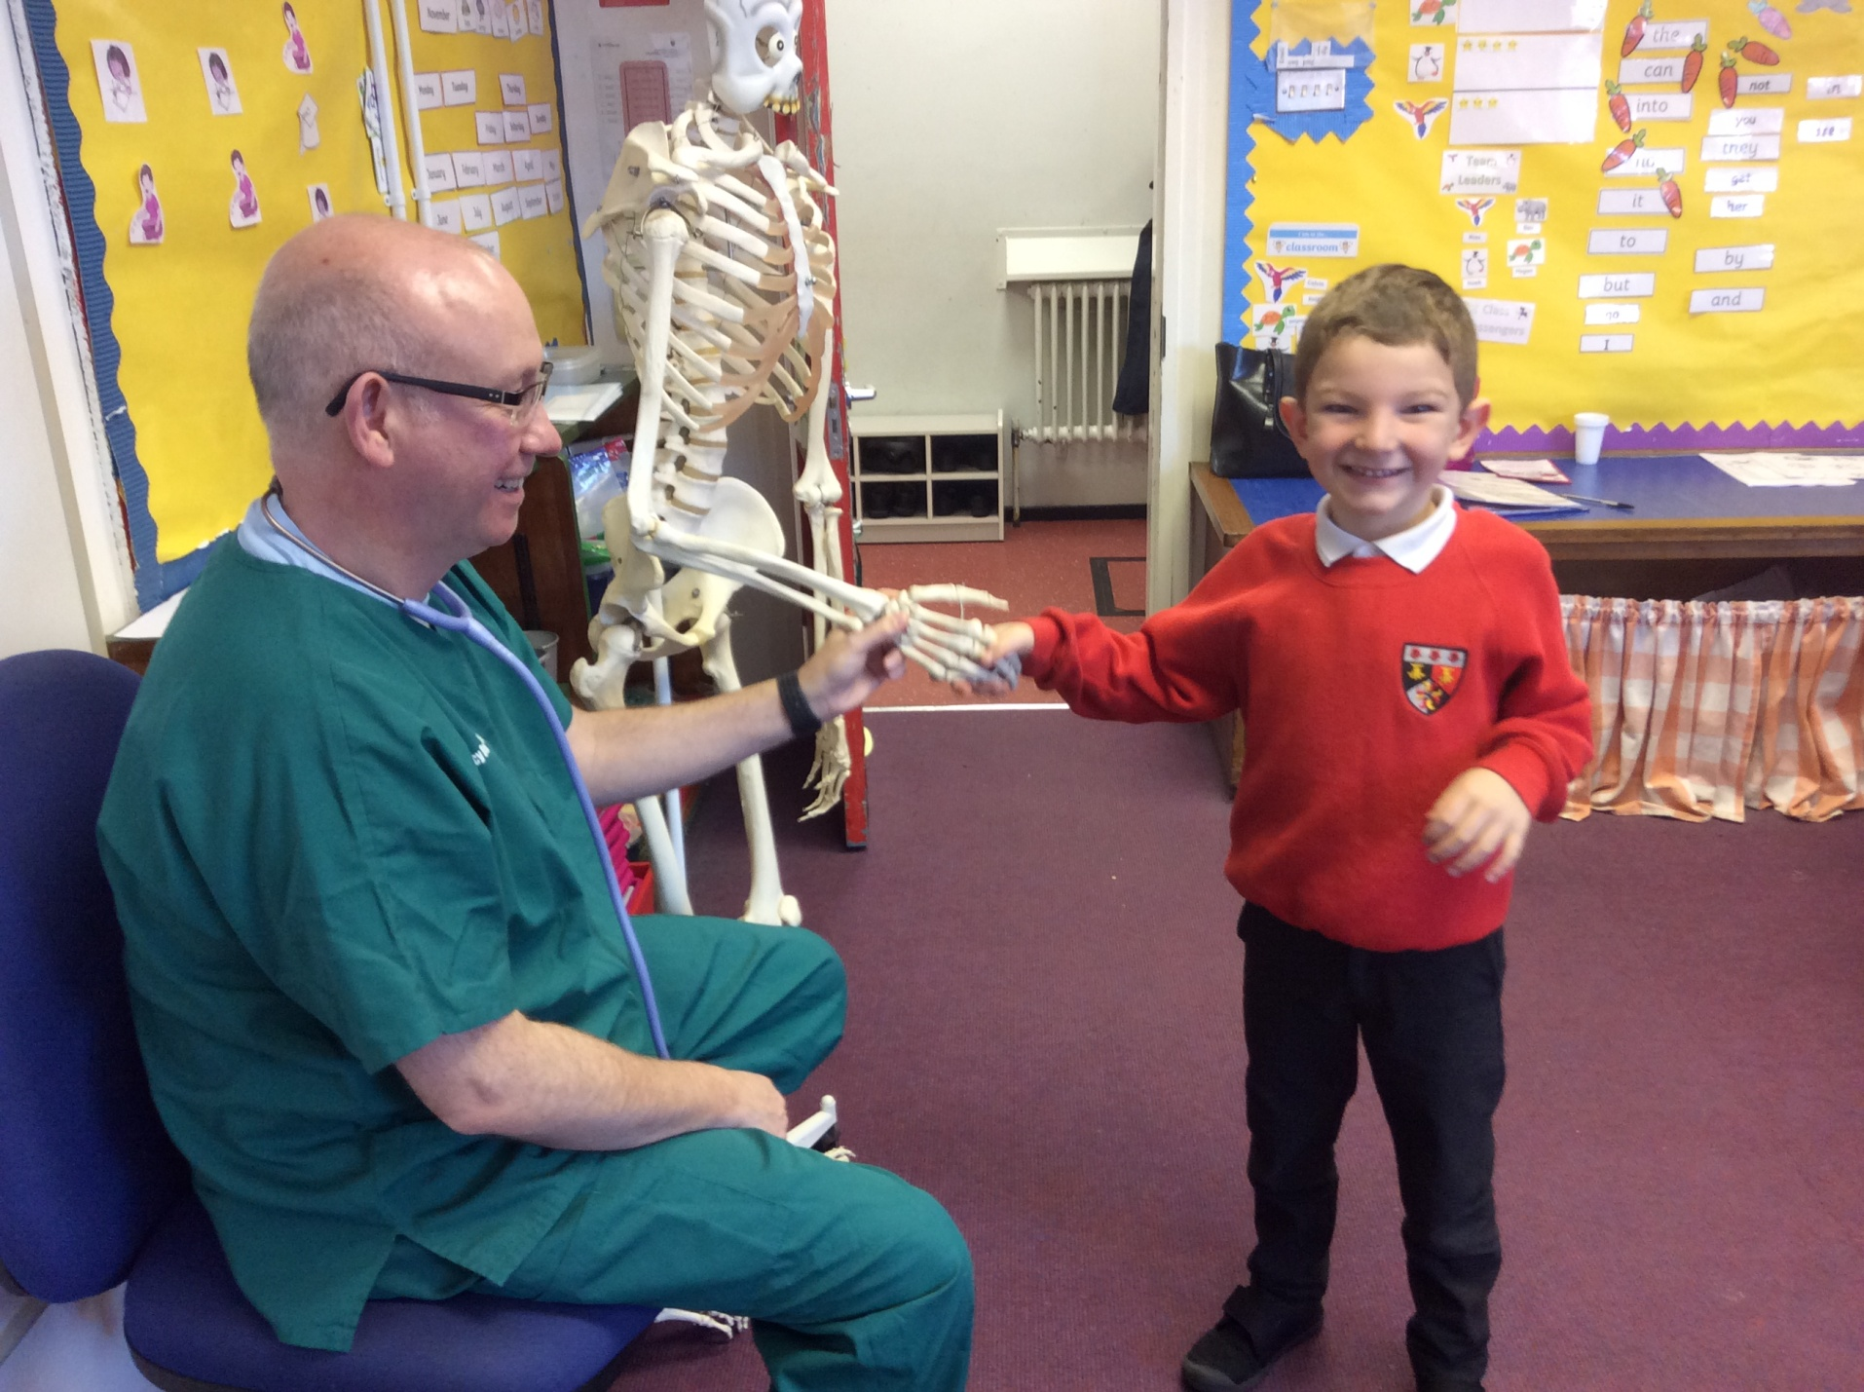

“We had great fun meeting Mr Skeleton“.

