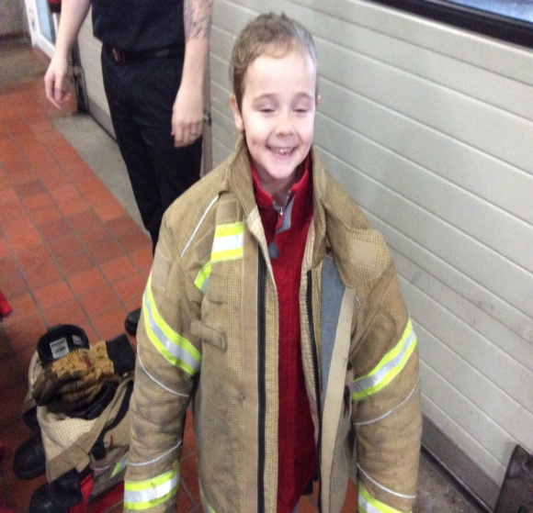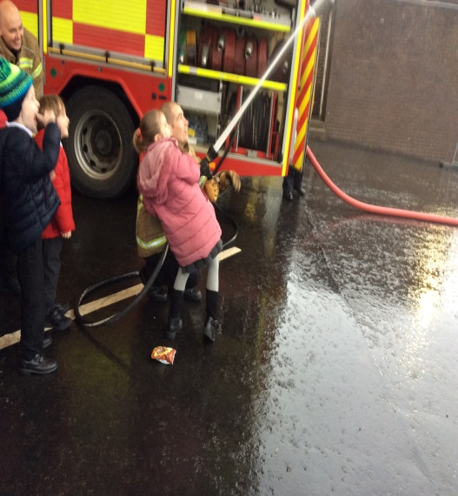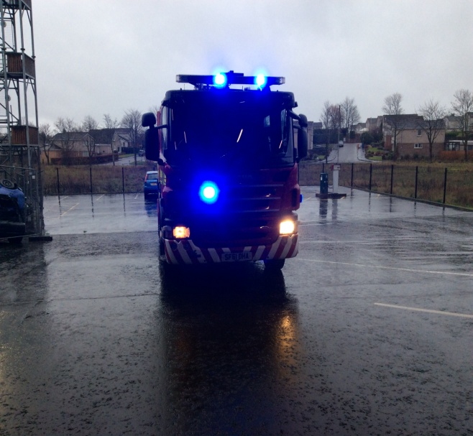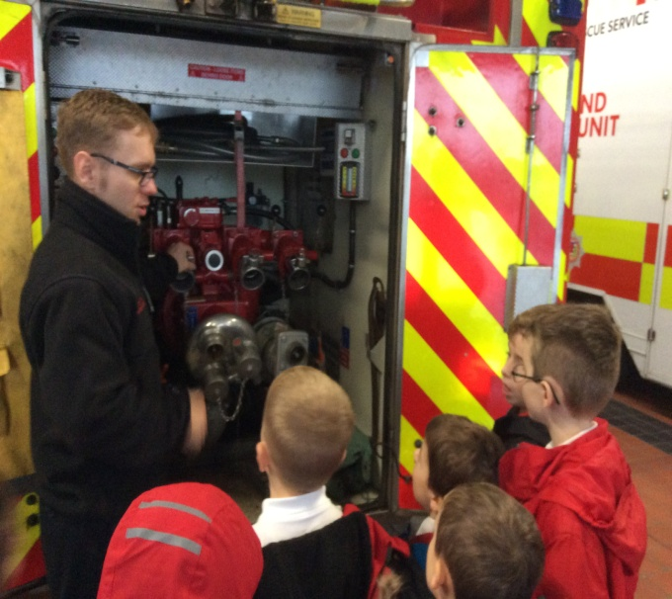
Here we are on a fantastic visit to Milngavie Fire Station. We learned how to use the hose, about all the tools and equipment the fire fighters use and about how to keep safe in an emergency. Thank you so much to the fire fighters for welcoming us and teaching us so much. We have used this information to design our own fire engines, think about skills for work and plan for emergencies. A big thank you to our parent helpers who make our trips possible.
