We have been working really hard this term on planning and running our “Elf Factory” business. We discussed job roles, products to sell, business names, how to make a profit and also what we would like to do when we are older.
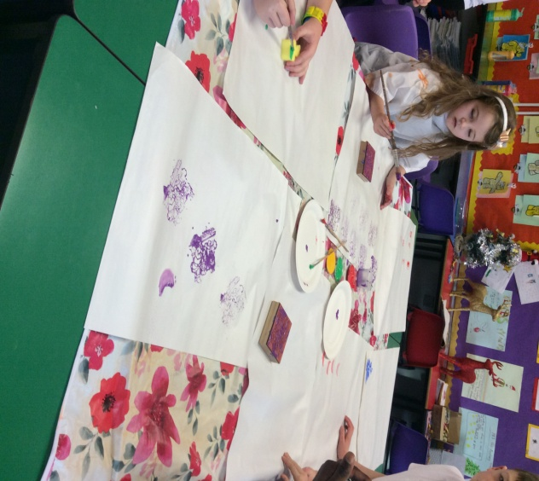
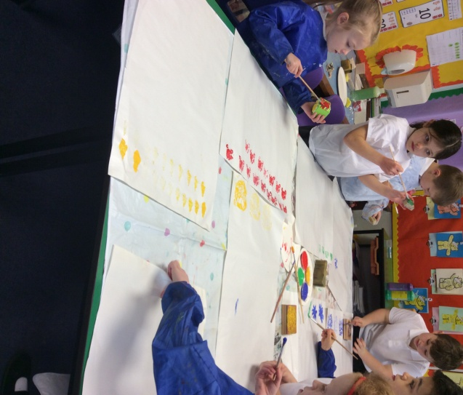

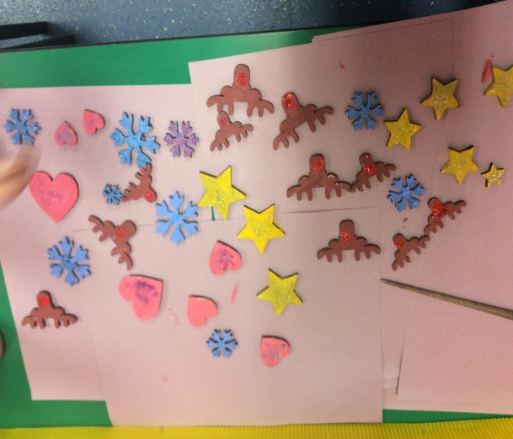
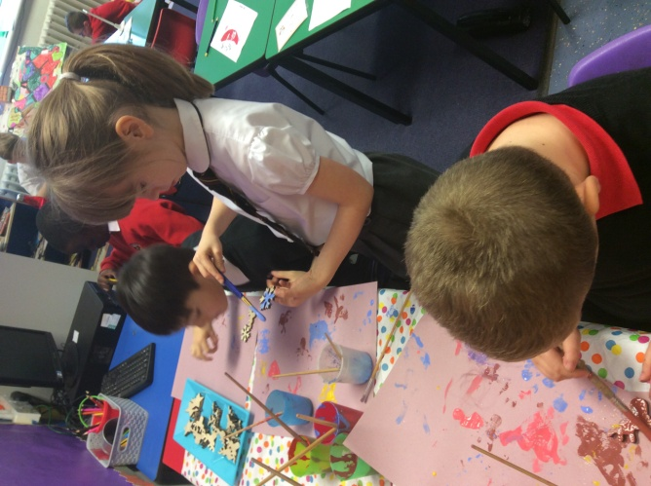

Here is an example of the lovely wrapping paper and tree decorations we designed.
We sold the products we made at The Winter Fayre and made a profit of £35 to go towards games for our class.
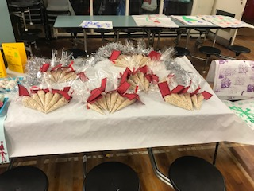
Thank you to everyone who bought our products
