Website Dec 2018-12-14

P4b Science Term 1
P4b have been very busy this term investigating materials in their Science topic. They know that some materials are manmade like plastic and others are natural like cotton. The children tested the strength of carrier bags, designed and made boats that sailed across a tank and even tested a variety of materials to find out if they were waterproof. They really enjoyed these practical activities and decided that leather is a hard wearing, natural material that can keep us dry !
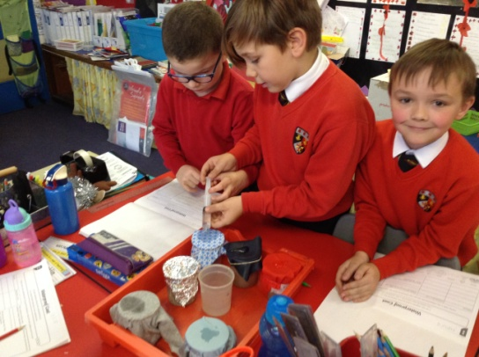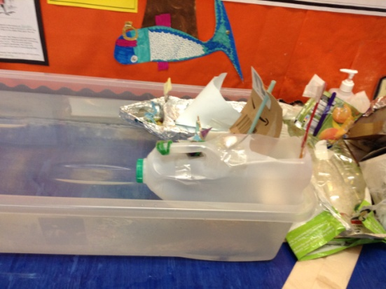
Testing how waterproof a material is...... Boat designs.........

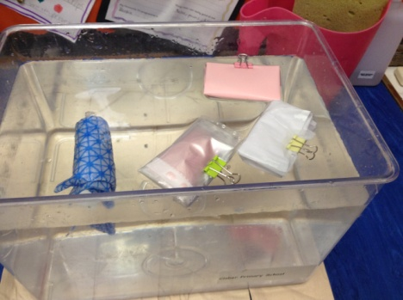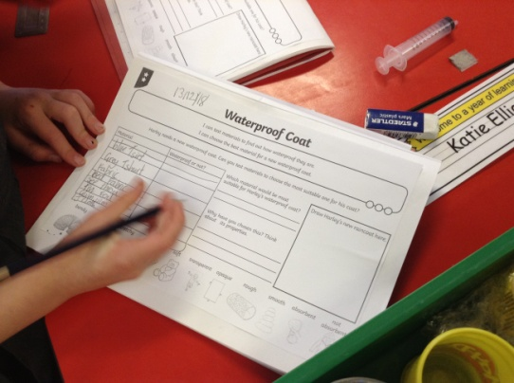
Surprising results from our water tank investigation... Recording our findings.......
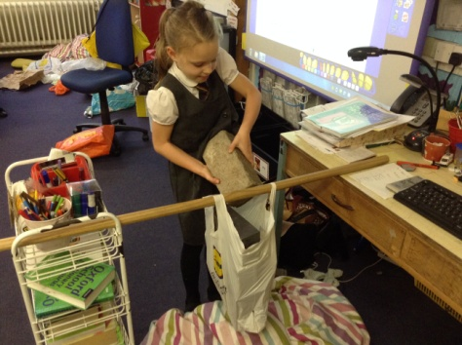 Plastic bags are incredibly strong as you can see....

Christmas Party Dec 18
We had lots of fun at our Christmas party playing games and dancing to some traditional Scottish Ceilidh tunes. Some pupils were lucky enough to win prizes! The party food and juice in the dining hall was just what we needed for the second half of the party. It was great fun!
