P6 have had a busy term learning about the rainforest. This culminated in a visit to Amazonia, an indoor rainforest at Strathclyde Country Park. The visit showed the pupils many of the animals and habitats they’d been learning about and allowed them to experience the heat, humidity and noise of the rainforest for themselves.
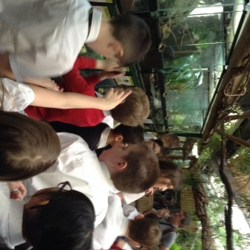
After that we had an animal handling session with Eva the Royal Python, Gordon the Gecko and a pair of Giant African Land Snails. Our teacher was standing well back!
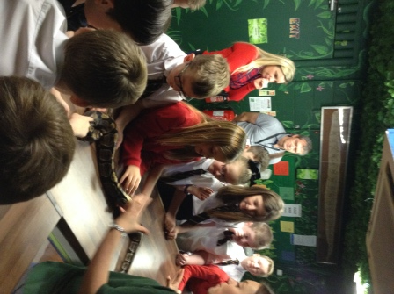
P6 have been reading for pleasure and passing on this love of books to younger pupils. We had a most enjoyable morning reading with some of the pupils from P1. 