A Busy Term in P7
We have been working hard and having lots of fun this term. Here are some of the things the class have chosen as their highlights:

Art
We have been focussing on blending in art and have created some beautiful pieces of work using charcoal, watercolour paints and poster paints. These created quite different effects but we were very pleased with the outcome. Here are some examples of our fantastic work:
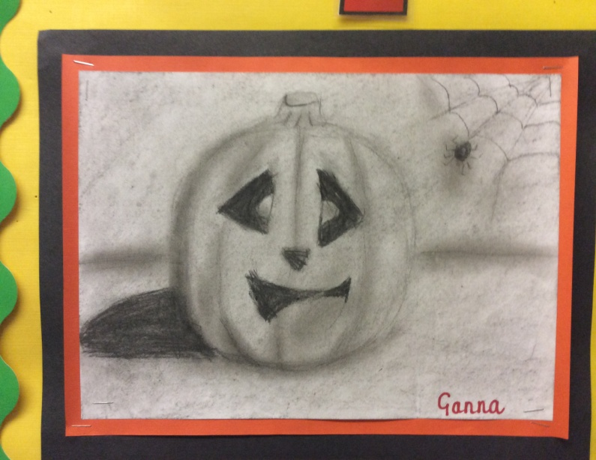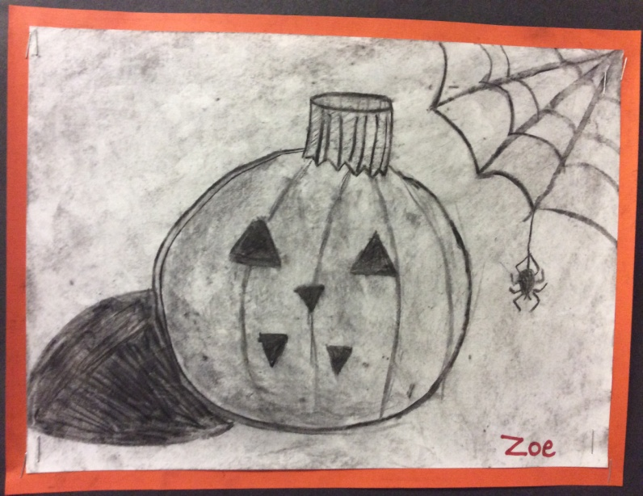
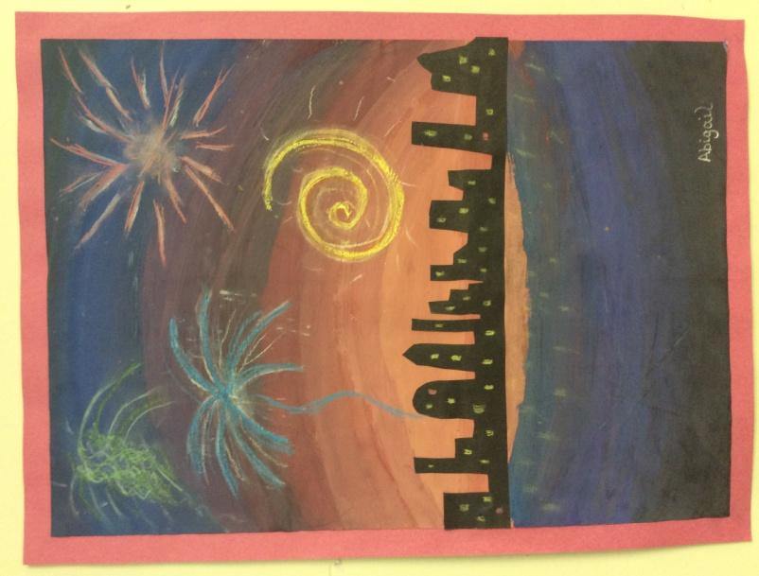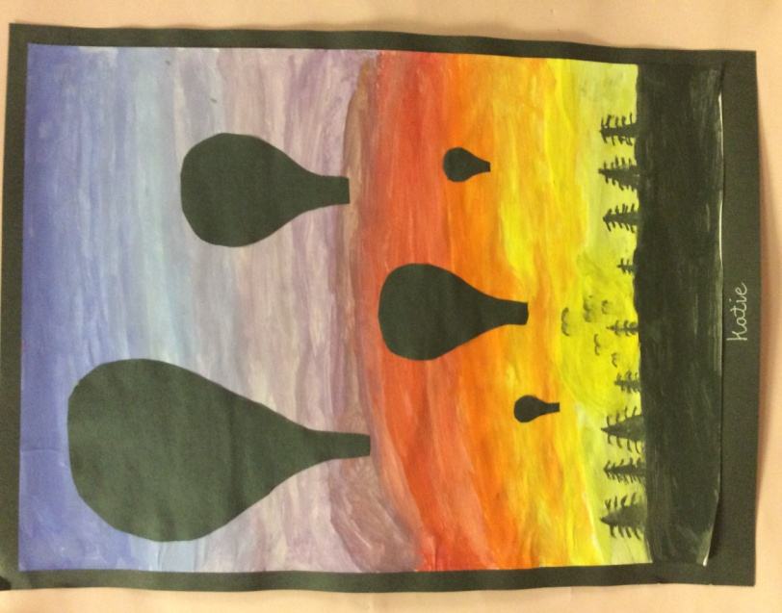

Angles
In maths we have been learning about angles. We have discussed why they are important and the types of jobs where we might need to use our knowledge of angles. So far we have looked at types of angles, angles in a triangle, drawing angles and corresponding angles. We will continue with this in the New Year.

Christmas Party
On Wednesday 19th December we had our P7 Christmas Party. As it was our last ever one at primary school we decided to do lots of traditional party games like pass the parcel, musical arms etc. As well as lots and lots of dancing. Thank you to all the parents for the very generous donations of food – we were all stuffed!!! We ended the party with everyone joining in for the Hokey Cokey.
